**School Comparison Assistant**

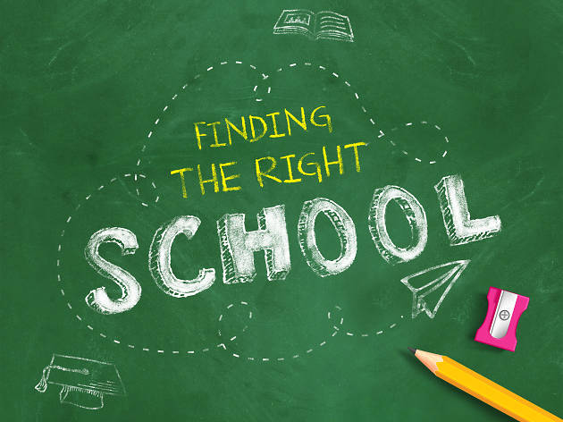

**Project description:**

Easy and simple to work with assistant comparing Sofia schools results after 4th grade. Target group of this assistant are people without experience in Excel or other table view instruments. According to my observation many parents are not able to find, assimilate and compare school results information when choosing a school for their child before 1st grade. School Comparison Assistant’s goal is to help them review the imported data easy and with minimum PC skills needed.

**Tech stack:**

* Python
* Pandas
* Excel
* Microsoft Office
* Google research

**Project skeleton options:**

1 - School basic introduction

'2 - Compare with the average results

'3 - Compare with the top result

4 - Comparison between two schools

5 - School progress in the years

6 - Which is the best private school

7 - Which is the best public school

8 – Exit

**Resourses**:

<https://ivandavidov.github.io/nvo/4/?i4=7,9,18,29,97,100,110,115,128,135,163>